Powder Material

Ti-6Al-4V High Performance Titanium is a high-performance alloy characterised by having excellent mechanical properties with a low specific weight and good corrosion resistance. Titanium and its alloys have been used successfully in the automotive and aerospace industry since the 1950s. Furthermore, titanium stands out through thermal expansion coefficient. Due to titanium’s biocompatibility, it can also be used in medical technology. Thus, implants for dentistry or individual hip implants can be manufactured of Ti-6Al-4V ELI Grade 23 (extra low interstitials, small amount of interstitial iron and oxygen atoms). Components made of TiAl6V4 show a homogenous, nearly non-porous structure, with mechanical characteristic values in the range of material specifications. Through subsequent processing such as heat-treatments (e.g. stress-relief annealing, recrystallization annealing, precipitation hardening) or hot isostatic pressing (HIP), the components’ properties can be adapted to meet specific requirements.

Physical Properties
Particle Size | 15 – 45 µm
Density | 4.5 g/ cm³
Thermal conductivity | 6 – 8 W/mK
Melting range | 1635 - 1665 °C
Thermal expansion | 8 x 10⁻⁶ K⁻¹ – 9 x 10⁻⁶ K⁻¹

Chemical Composition
Ti | Balance | O | < 0.13 %
Al | 5.5 – 6.5 % | C | < 0.08 %
V | 3.5 – 4-5 % | N | < 0.05 %
Fe | < 0.25 % | H | < 0.012 %

LPBF Process
Layer Thickness | 30 µm
Laser Power Classification | 200 W
Theoretical Build-up Rate | 8.6 cm³/h

Denstiy
Relative Density > 99.5 % | 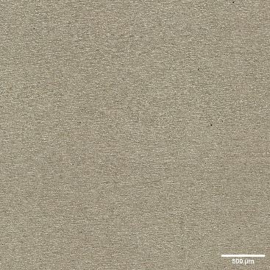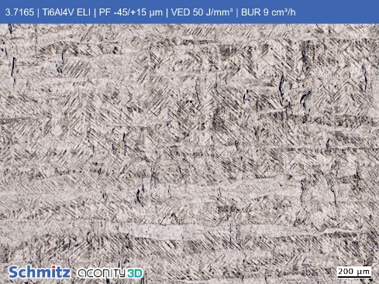

Dimensional Accuracy
 | As Built | Sand Blasted
Tolerance | ± 250 µm or 1 %* | ± 160 µm or 1 %*
Minimum Wall Thickness (Vector) | 130 µm
* Whichever is greater. Evaluated on test artifact sample (see https://aconity3d.com/job-shop) and dependent on geometrical feature and size.

Mechanical Properties – As built According to DIN EN ISO 6892-1
Orientation | Young’s Modulus [GPa] | Yield Strength  R_{p0,2} [MPa] | Tensile Strength  R_{m} [MPa] | Elongation at Break A_{x} [%]
0°  (vertical) | 117 ± 11 | 894 ± 30 | 1087 ± 12 | 9 ± 3
45° | 127 ± 6 | 1039 ± 22 | 1220 ± 11 | 6 ± 1
90°  (horizontal) | 121 ± 2 | 953 ± 12 | 1157 ± 6 | 9 ± 1

Mechanical Properties – Heat Treated¹
Orientation | Yield Strength  R_{p0,2} [MPa] | Tensile Strength  R_{m} [MPa] | Elongation at Break A_{x} [%]
0°  (vertical) | 825 | 895 | 10

Surface Roughness
Condition | As Built |  |  | Sand Blasted
Orientation  relative to platform | 40° | 60° | 90° |  | 40° | 60° | 90°
Ra vertical [µm] | 21 ± 3 | 13 ± 3 | 12 ± 2 |  | 13 ± 1 | 8 ± 2 | 8 ± 2
Ra horizontal [µm] | 22 ± 5 | 15 ± 2 | 13 ± 2 |  | 14 ± 2 | 9 ± 2 | 7 ± 1
Rz vertical [µm] | 142 ± 32 | 89 ± 22 | 73 ± 17 |  | 86 ± 9 | 56 ± 11 | 46 ± 12
Rz horizontal [µm] | 150 ± 28 | 99 ± 19 | 81 ± 12 |  | 89 ± 16 | 62 ± 13 | 51 ± 12
Sa [µm] | 12 ± 1 | 9 ± 1 | 8 ± 1 |  | 5 ± 1 | 3 ± 1 | 3 ± 1
Sz [µm] | 176 ± 27 | 114 ± 13 | 108 ± 18 |  | 93 ± 27 | 61 ± 7 | 53 ± 11

All values are related to the standard process of Aconity3D and are subject to natural volatilities depending on applied powder material, process parameters and surrounding conditions. Changes in laser spot size and other process conditions might have an influence on the values.
¹ Classification A, according to ASTM F2924 - 14
² Minimum specifications according to ASTM F2924 - 14

